Creating a New Account on Turnitin.com!
- Go to: http://www.turnitin.com
- Click on “Create Account” under the username textbox.

- On the next screen scroll to the bottom and click on the “Student” Link

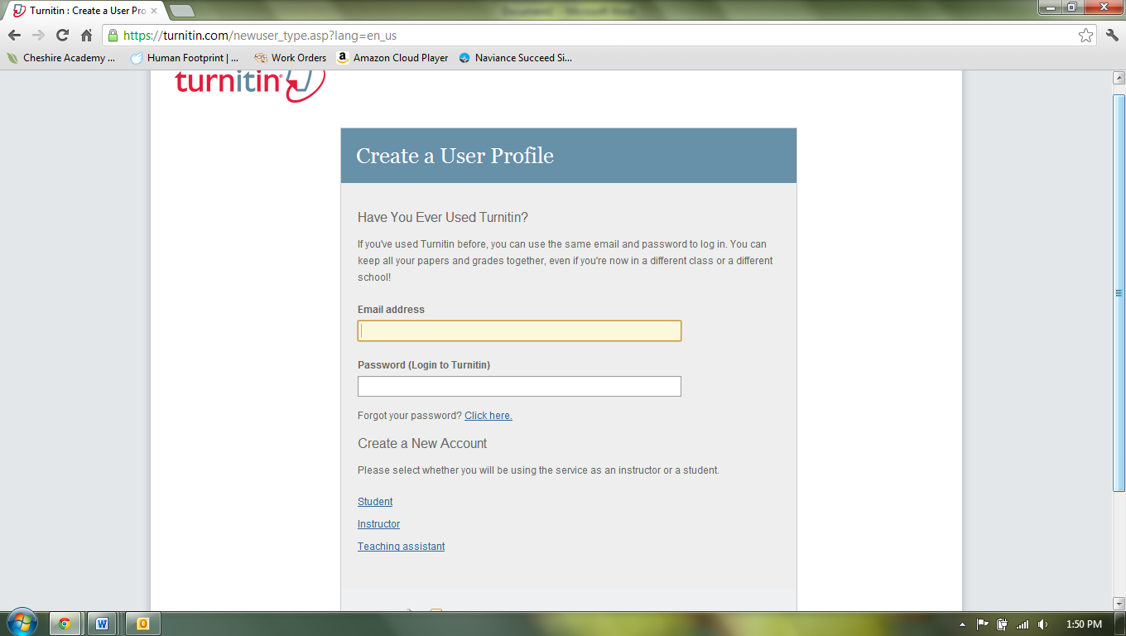

- Enter the class ID and the password as listed on the blog, be sure you use the codes for your class period.
- Enter your first and last name and your email.
- Choose a password that you will remember.
- Put in a security question and answer.
- Click on “I agree—Create Profile”
- It will bring you to a screen then that allows you to see the class you have enrolled in.

