IBSL Chemistry Summer Review Packet - 2020
Ms. Riske
www.riskescience.com
korin_riske@beaverton.k12.or.us

I am so looking forward to having you in IBSL Chemistry with me in the Fall, please know it will be in-depth, fast paced and rigorous …but most of all it will be fun!! This course will challenge you to not only advance your (already superb) chemistry knowledge, but also to develop your critical thinking problem solving and inquiry skills. I believe that learning to think and learn is much more important than learning facts (though we will need to hit those as well). So please come into my class prepared to take responsibility for your own learning. I can provide resources, opportunities, advise, insight and support, but the only person who can help you to truly succeed and thrive in this class is yourself.
Completion of this packet is required, and will be due the first day of school. The packet is graded. Use the check sheet at the end of the packet to be sure you have completed all the necessary work and use that sheet as the cover page for the work you will be turning in.
Packet Contents:
- REVIEW (*this is the content you need to complete and turn in on the first day of school)
  - Things you should know (annoying but useful memorization)
  - Vocabulary
  - *Lab Safety
  - *Topic Review Activity
  - *Review Problems
  - *Challenge Problems
  - *Summer Review Check Sheet

Internet Resources: Richard Tornley’s IB Chem videos on youtube are great, Khan Academy Chemistry, Chemguide – UK, Also my website (riskescience.com) has links to many useful resources including some relevant chapters from the IB chem text book.

Course Outline
(With approximate test dates
Semester 1 |  | Semester 2
Unit 1 | Unit 2  Semester 1 Final Jan 20 | Unit 3 | Unit 4  Cumulative Final May 20
Topics 1-4:  Mid Term 1 Oct. 30  Stoichiometric Relationships  Atomic Structure  Periodicity  Chemical Bonding | Topics 5-8:  Thermochemistry  Chemical Kinetics  Equilibrium  Acids and Bases | IA:  Independent Lab  Topics 9-11:  Redox Processes  Organic Chemistry  Measurement and Data Processing | Option D:  Mid Term 2 April 15  Medicinal Chemistry  Review - Exam  Materials Science Fun Time

THINGS YOU SHOULD KNOW
Some Common Polyatomic Ions
You need to know the names and formulas (including charge) of the following polyatomic ions.

Ammonium ion, NH₄⁺
Hydroxide ion, OH⁻
Nitrate ion, NO₃⁻
Hydrogencarbonate ion, HCO₃⁻
Carbonate ion, CO₃²⁻
Sulfate ion, SO₄²⁻
Phosphate ion, PO₄²⁻

Some Common Strong Acids and Bases
You need to know the names and formulas of the following strong acids and bases.

Strong Acids
Hydrochloric acid, HCl
Nitric acid, HNO₃
Sulfuric Acid, H₂SO₄

Strong Bases
Lithium hydroxide, LiOH
Sodium hydroxide, NaOH
Potassium hydroxide, KOH
Barium hydroxide, Ba(OH)₂

SI Units and Conversions
You need to know all of the SI units below and how to convert between magnitudes.
Property | Unit | Symbol
Mass | gram | g
Time | second | s
Temperature | Kelvin | K
Volume | cubic meter | m³
Pressure | Pascal | Pa
Energy | Joule | J

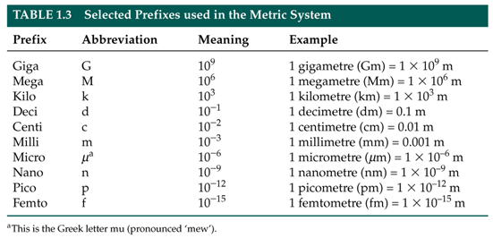
Vocabulary

Stoichiometry
Mole ratio
Avogadro’s constant (number)
Molecular formula
Empirical formula
Element
Atom
Compound
Proton
Neutron
Electron
Isotope
Ion
Relative atomic mass
Period (on the PT)
Group (on the PT)
Transition elements
Alkali metals
Alkaline earth metals
Halogens
Noble gases
Ionization energy
Atomic radius
Electronegativity
Physical property
Physical change
Chemical property
Chemical change
Melting point
Boiling point
Ionic bond
Covalent bond
Cation
Anion
Conductivity
Sublimation
Reactants
Products
Solute
Solvent
Solution
Precipitate
Molarity
Aqueous
Saturated
Unsaturated
STP
Kinetic Molecular Theory
Catalyst
Chemical reaction

Lab Safety
Lab Safety Assignment: Complete the activities listed below.
- Watch a couple chemistry lab safety videos on YouTube and compile one page of notes that summarize everything you should know about lab safety.

- Choose two accident scenarios from the list below and demonstrate (with a paragraph, comic, flow chart, etc …) that you know how to respond to the situation.

  - A stock bottle of a chemical tips over and breaks.
  - A Bunsen burner catches some papers on fire at your lab station
  - A student’s sleeve catches fire
  - Some chemical splashes and gets on your face and clothes
  - You knock over your beaker full of boiling water and it breaks

- On a separate sheet of paper, identify the following lab equipment and give an example of what it might be used for.

a. 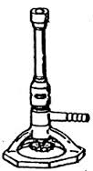 b. c.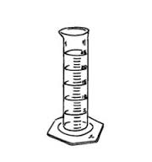d.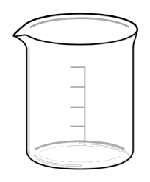 e. 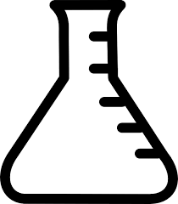 f. 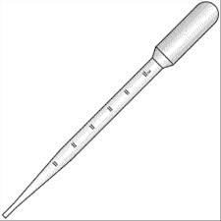 g. h.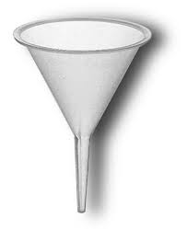

STEM to IB - What do you already know? … A lot!

For each of the topics covered in STEM Chem go through the IB syllabus statements and highlight the topics you know in one color, and the ones you don’t (either because you missed it at the time or it wasn’t covered in your STEM Chem class) in another color. We will be using these highlighted documents for one of our first activities in the fall. The IB topics that we covered (at least in part) in STEM Chem are listed below and the syllabus statements are linked at www.riskescience.com .

      - Topic 1: Stoichiometric Relationships
      - Topic 2: Atomic Structure
      - Topic 3: Periodicity
      - Topic 4: Chemical Bonding & Structure

Topics 1-4 will be covered on our first mid-term. It is critical that you come with your STEM Chem knowledge to build off of during our packed first unit.

REVIEW PROBLEMS

On a separate sheet of paper, answer the questions below. If you don’t remember a topic, use your STEM Chem notes and the Internet sources provided above to review. To be considered complete for credit all problems must be attempted with all work shown.

1) Convert 4,672,000,000 into scientific notation.
2) Convert 0.000005210 into scientific notation.
3) Convert 50.0 g to milligrams.
4) Convert 150. dm³ to liters.
5) How many significant figures are in the number 4.0070 x 1012?
6) An object has a mass of 40.1g and occupies a volume of 8.20 cm³. What is the density of the object?
7) Calculate the percent yield if 28.0g of MgCl2 is produced, but 32.0g of MgCl2 should have been produced.
8) How many atoms are in 52.4g of nickel?
9) 6.00g of water contains how many moles of water?
10) What is the molar mass of methane?
11) How many hydrogen atoms are in 3.0 moles of ethanol, C₂H₅OH?
12) What is the empirical formula of glucose, C₆H₁₂O₆?
13) A compound with an empirical formula of CH₂ has a molecular mass of 42.09. What is its molecular formula?
14) A compound of nickel has a mass composition of 37.9% nickel, 20.7% sulfur, and 41.4% oxygen. What is its empirical formula?
15) Aluminum and iron(III) oxide react to form iron and aluminum oxide. What mass of iron is produced from the reaction of 21.4g of aluminum and 91.3g of iron(III) oxide? What is the limiting reactant? What is the excess reactant?
16) What volume of nitrogen forms when 100. g of ammonia, NH₃, decomposes completely into its elements at STP?

17) Determine the number of protons, neutrons, and electrons for each:
a. Sulfur
b. Chloride
c. Calcium ion
d. ¹²⁷I

18) Which is larger? Ca or Ca⁺² Why?
19) Why is sodium larger than chlorine?
20) Why is fluorine smaller than iodine?
21) Why does it take less energy to remove an electron from Potassium than from Bromine?
22) List the following elements in order from smallest to largest electronegativity: Magnesium, Sulfur, Francium
23) Write full electron configurations for Na, Al, and Cl¹⁻
24) Draw dot diagrams for Nitrogen and Fluorine.
25) Draw the Lewis structures for NH3 and CO2.
26) Discuss how intermolecular forces determine the physical properties of a substance.
27) Write and balance chemical equations for:
a. The combustion of methane
b. The single replacement reaction of zinc and hydrochloric acid
c. The double replacement reaction of sodium hydroxide and barium nitrate.
d. The decomposition of dinitrogen pentoxide to its elements.

Challenge Problems
On a separate sheet of paper, solve the following problems. These “challenge” problems are designed to make you use all of your chemistry knowledge to solve an integrated problem. I would follow the following procedure when approaching these problems:
- Dissect the problem
  - Identify the question being asked
  - Identify what information the problem is giving you
- Make a plan to solve
  - Determine what information you need to answer the question
  - Determine what you need to do the get the information from step 3
- Solve the problem
  - Do the work identified in step 4
  - Answer the question (Using the information from the above steps)
- Check to be sure your answer makes sense.

- The white limestone cliffs of Dover, England contain a large percentage of calcium carbonate. A sample of limestone with a mass of 84.4g reacts with an excess of hydrochloric acid to form calcium chloride water and carbon dioxide gas. The mass of calcium chloride formed from this reaction is 81.8g, what is the percentage of calcium carbonate in the limestone?

- Two elements are to be combined to form a balanced compound. The first element, M (fictitious), has two valence electrons. The second (fictitious) element, X, has five valence electrons. Show, using Bohr models and describe using words how many M’s and how many X’s will come together to form a balanced ionic compound.

- The following information concerns six consecutive elements in the periodic table. Study the information carefully and then identify each element.

Element A is a diatomic gas at room temperature. It combines with element B to form a compound B₂A.

Element B reacts with water to produce heat and causes rapid movement across the surface of the water. Element B reacts with element F to form the compound BF.

Element C is a diatomic gas at room temperature. 22.4 liters of the gas at 0°C and a pressure of 1.0 atm weighs 28.0g.

Element D is a gas that does not form compounds with anything.

Element E is a non-metal solid that in some forms can conduct electricity moderately. It combines with element A to form common compounds EA and EA₂.

Element F exists as a diatomic gas at room temperature. It is the most reactive nonmetal of all the elements in this question.

- A fundamental feature of stoichiometric calculations and using dimensional analysis is the canceling of units. Using the following equation and constant prove that the units do in fact cancel.
R = 8.31 J K⁻¹ mol⁻¹ , pressure in Pa, temperature in K, n in mols, volume in m³
The ideal gas law states that PV=nRT, solve for R and prove that the units are equal on both sides of the equation. (some research into units may be needed here, the Internet will help)
Name________________________________per______date________

IBSL Chemistry Summer Review Packet - 2015 Check Sheet
Completed Review Work is Due on the First Day of Class with this sheet.
To be considered complete all problems must be attempted with all work shown.
(Please check off each item when you have it completed, leave the points section for me.)

- Lab Safety Assignment /10pts
- Topic Review Assignment /10pts
- Review Problems /10pts
- Challenge Problems /10pts

Total /40pts

***Please share your hopes and fears for the class below. Your input is a critical piece data for my course design process. Thanks.

Hopes for the class:

Fears for the class:

Do you plan on taking the IB test? Yes or No

