Submitting your Lab Report!
After you have finished your lab report, you have read it over for grammar mistakes (and gotten rid of I, we, and me anywhere), save it to a location you can access easily such as the desktop.
- Go to http://www.turnitin.com.
- Log in with your e-mail and password.
- Click on your Chemistry Class Page.
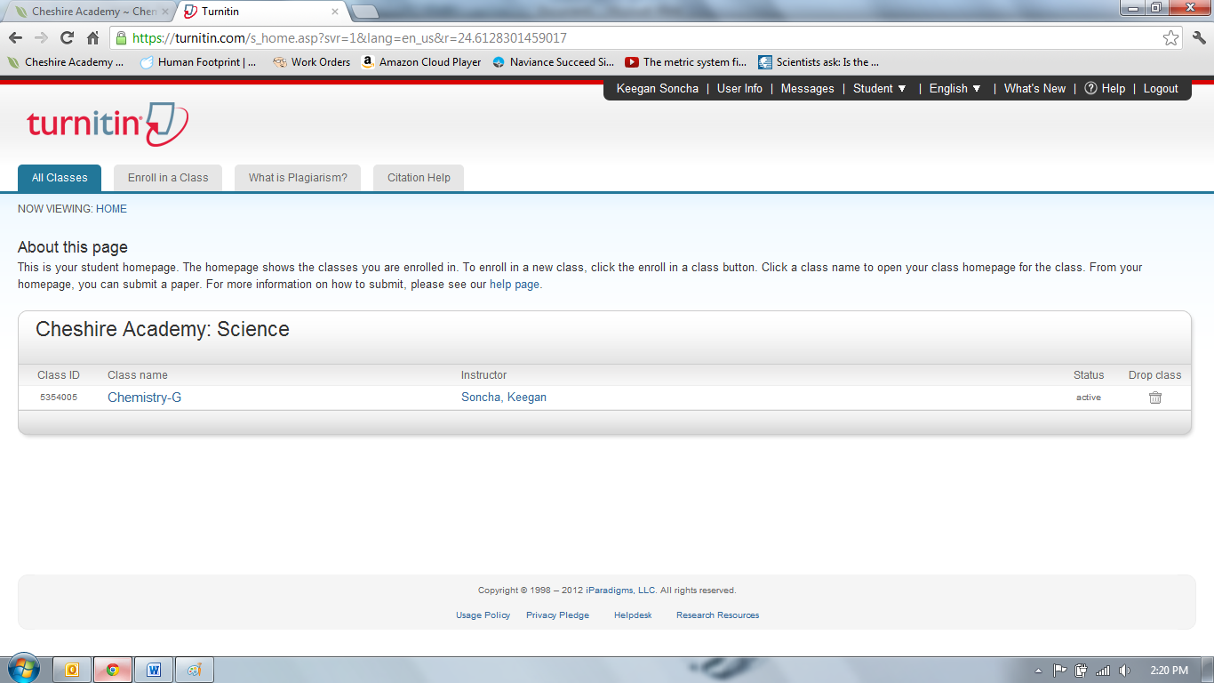
- Find the correct assignment and hit the “submit” button.
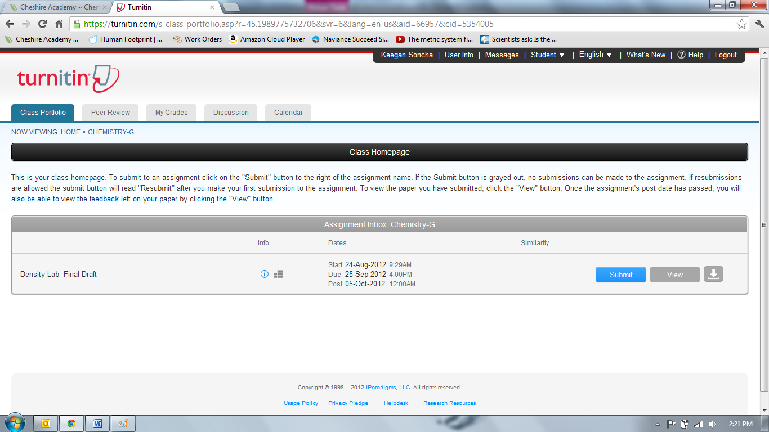

- On the drop down menu select “Single File Upload”
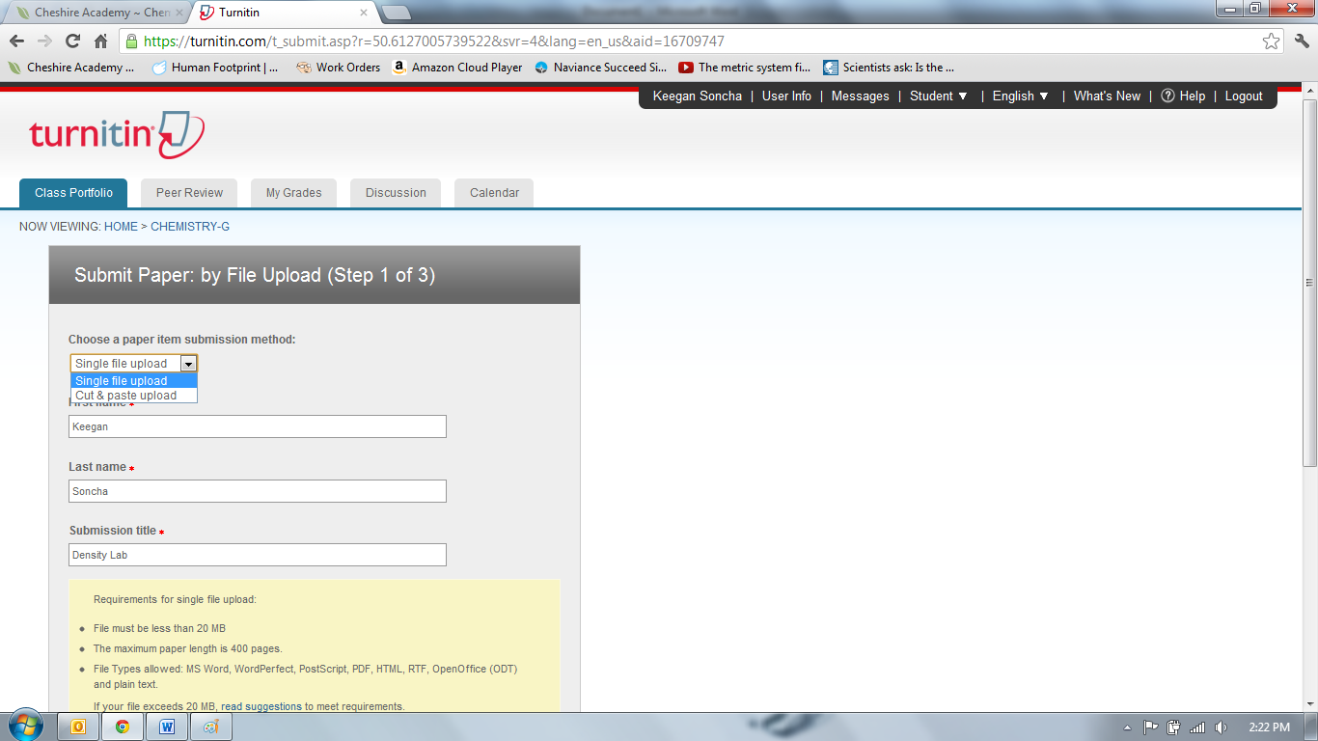
- Fill in your name and the title.
- Click Browse, find your file, and hit UPLOAD.
- On the next prompt you will get a preview. Your diagram will most likely not show up as it will only read text not pictures.
- Click SUBMIT. If you do not hit submit it will not be turned in to me.
- CHECK YOUR E-MAIL! You receive a receipt when it is submitted. In the receipt only text is shown so you will not be able to see your diagram on the receipt.
- If you wish to check your document (and I suggest that you do). Click ‘Home ‘ at the top of the page.
- Go back into the class page (like step 3 above)
- You will see now two buttons. You will see a “resubmit” button and a “view” button. If you click the view button you will be able to see exactly what was submitted.
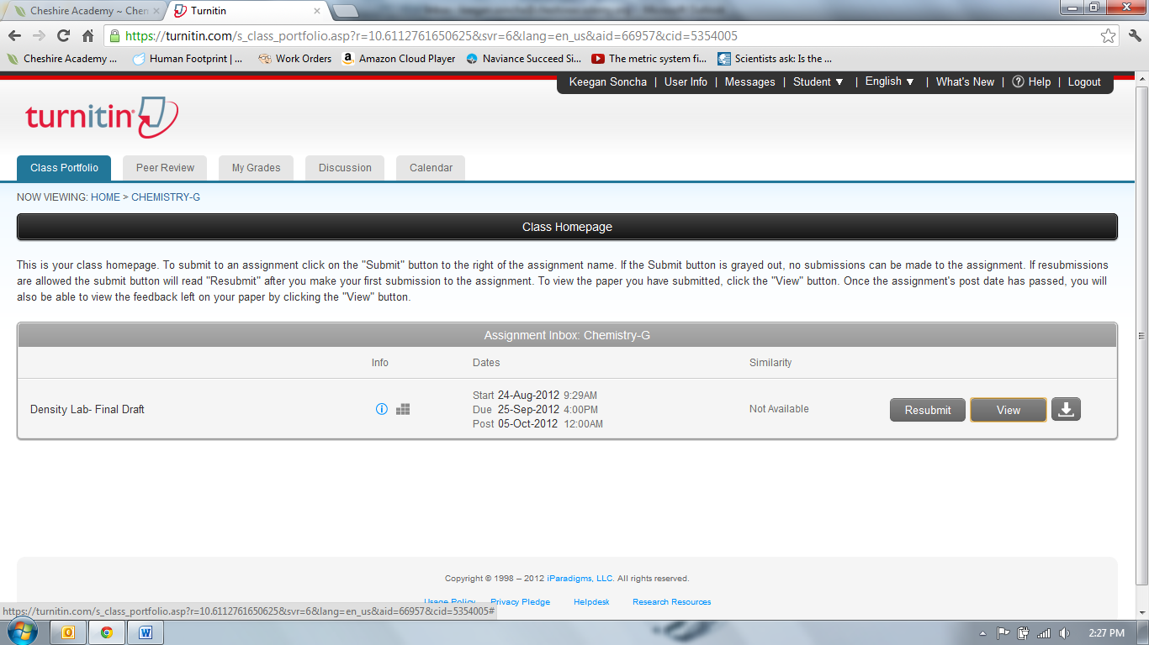
If after you view (scroll all the way down) you realized you made a mistake you can upload your paper as many times as you would like until the due date and time. The last upload that you put in will be the one that I see.

